# Install Cassandra on Ubuntu

Table of Contents

Install Cassandra on Ubuntu 1

Ubuntu 1

VMWare with Ubuntu 1

DANISH KEYBOARD 6

INSTALL UPDATES 6

CURL (used to install Cassandra) 6

INSTALL JAVA 7

INSTALL CASSANDRA 7

CONFIGURE CASSANDRA 8

STATIC IP 9

START CASSANDRA 10

TELNET (to test connectivity with the host if needed) 11

## Ubuntu

**P:\_Medarbejder\JP\Ubuntu\ubuntu-14.10-desktop-amd64.iso**

## VMWare with Ubuntu

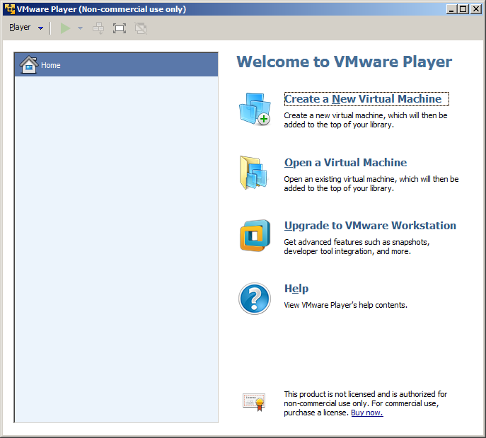

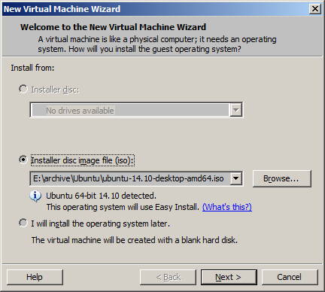

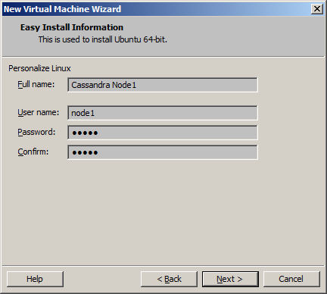

Password: node1

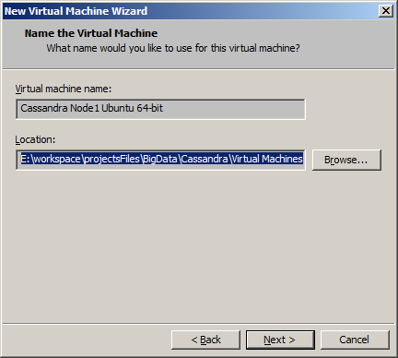

Location: E:\workspace\projectsFiles\BigData\Cassandra\Virtual Machines\CassandraNode1Ubuntu64-bit

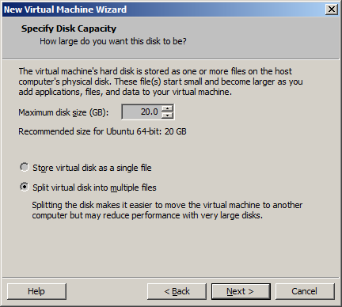

8 GB also works

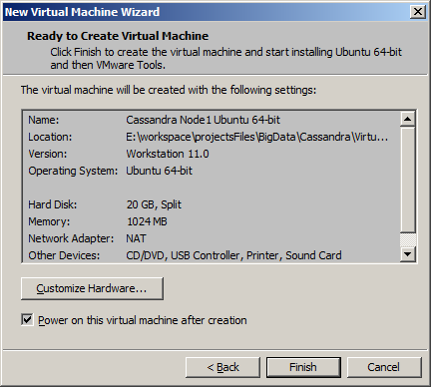

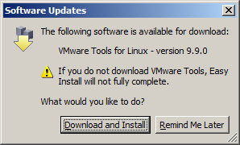

Download and Insta

## DANISH KEYBOARD

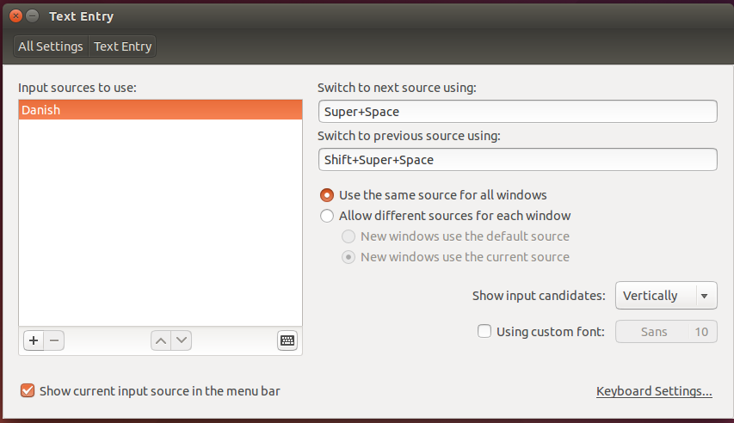

## INSTALL UPDATES

sudo apt-get update

sudo apt-get upgrade

## CURL (used to install Cassandra)

sudo apt-get install curl

## INSTALL JAVA

sudo add-apt-repository ppa:webupd8team/java

sudo apt-get update

sudo apt-get install oracle-java7-installer

sudo apt-get install oracle-java7-set-default

# Check Java alternatives

sudo update-alternatives --config java

## INSTALL CASSANDRA

curl -OL <http://mirrors.dotsrc.org/apache/cassandra/2.1.2/apache-cassandra-2.1.2-bin.tar.gz>

tar -xvzf apache-cassandra-2.1.2-bin.tar.gz

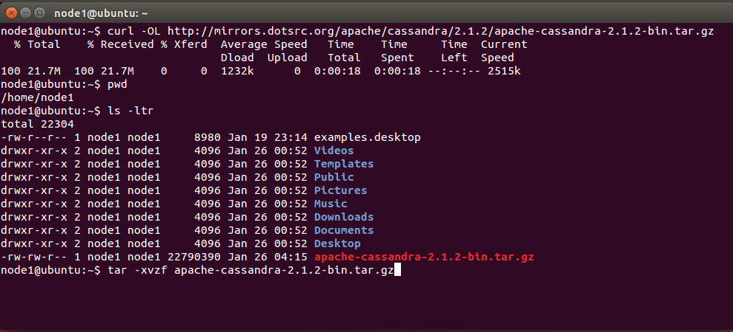

## CONFIGURE CASSANDRA

cd /home/node1/apache-cassandra-2.1.2/conf

vi cassandra.yaml

Modify the following property settings in the cassandra.yaml file for each node:

* num_tokens: <recommended value: 256>
* -seeds: <internal IP address of each seed node>
* listen_address: <localhost IP address>
* endpoint_snitch: <name of snitch> (See endpoint_snitch.)
* auto_bootstrap: false (Add this setting only when initializing a fresh cluster with no data.)

cluster_name: 'Cassandra Cluster'

num_tokens: 256

seed_provider:

- class_name: org.apache.cassandra.locator.SimpleSeedProvider

parameters:

- seeds: "192.168.15.130"

listen_address: 192.168.15.130

rpc_address: 0.0.0.0

broadcast_rpc_address: 192.168.15.130

endpoint_snitch: GossipingPropertyFileSnitch

vi cassandra-topology.properties

# Cassandra Node IP=Data Center:Rack

192.168.15.130=DC1:RAC1

# default for unknown nodes

default=DC1:RAC1

vi cassandra-rackdc.properties (can be left with default values)

# These properties are used with GossipingPropertyFileSnitch and will

# indicate the rack and dc for this node

dc=DC1

rack=RAC1

## STATIC IP

1. On the Windows host

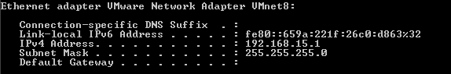

1. Take the IPv4 Address with 2 in the end as Gateway below:
   1. In this case 192.168.15.2

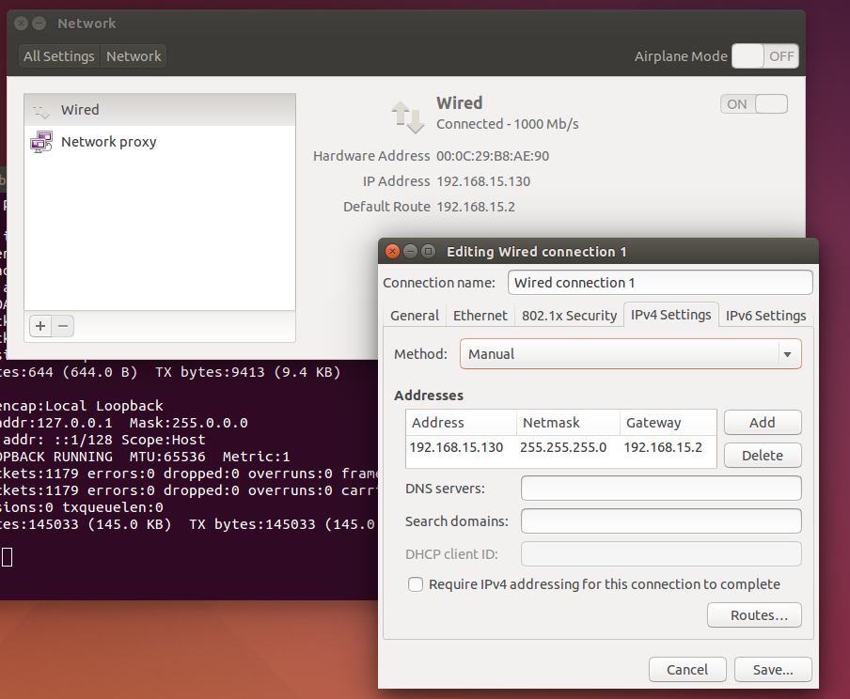

1. Re-boot Ubuntu
2. After restart:

NOTE, Internet access is not availble with static IP. Switch back to Auto if that is needed.

## START CASSANDRA

cd /home/node1/apache-cassandra-2.1.2/bin

./cassandra -f

## TELNET (to test connectivity with the host if needed)

sudo apt-get install telnetd

sudo apt-get install inetutils-inetd

inetutils-inetd start

Test that you can telnet from Windows to Ubuntu

telnet 192.168.15.130

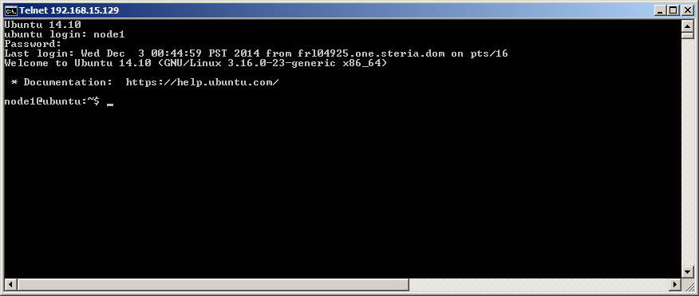

inetutils-inetd stop

# Copy an existing NODE

We want to copy Node 1 to a new VMWare Node 2

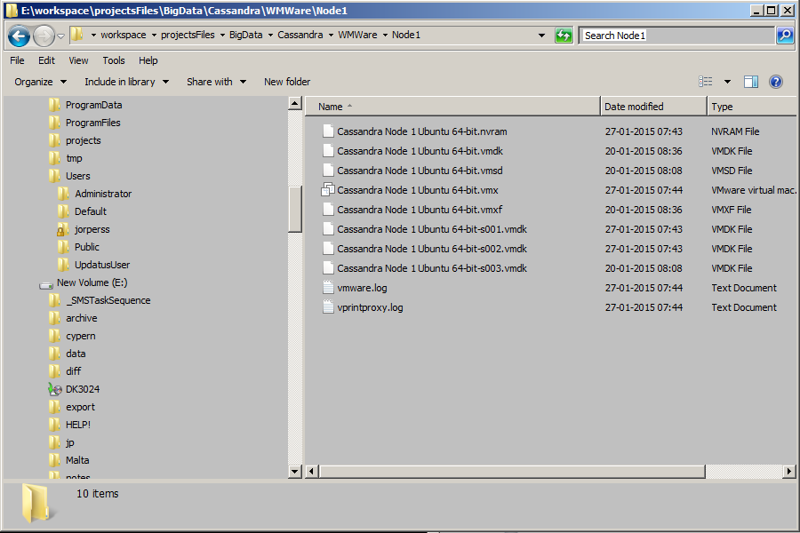

1. Copy the directory Node1 to Node2

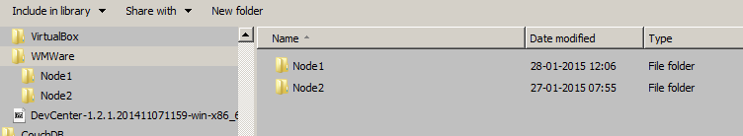

1. Change Node 1 to Node 2 in all file names

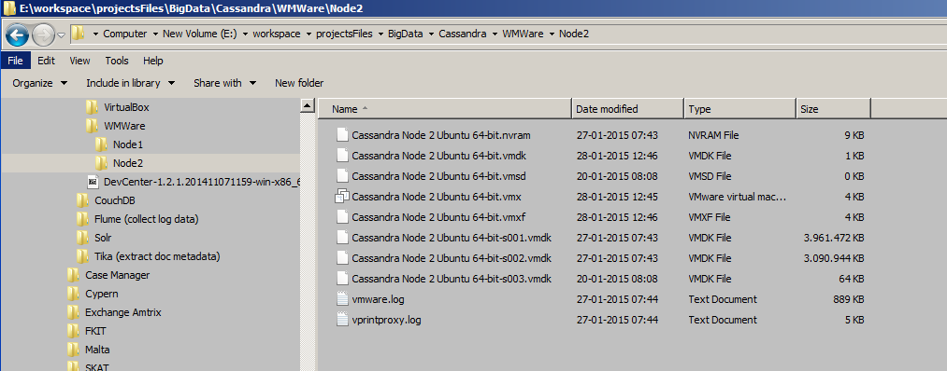

1. Change Node 1 to Node 2 inside this files:
   1. Cassandra Node 2 Ubuntu 64-bit.vmx
   2. Cassandra Node 2 Ubuntu 64-bit.vmxf
   3. Cassandra Node 2 Ubuntu 64-bit.vmdk
2. Start the new Node by double-clicking the VMX file
3. Click ‘I Copied it’

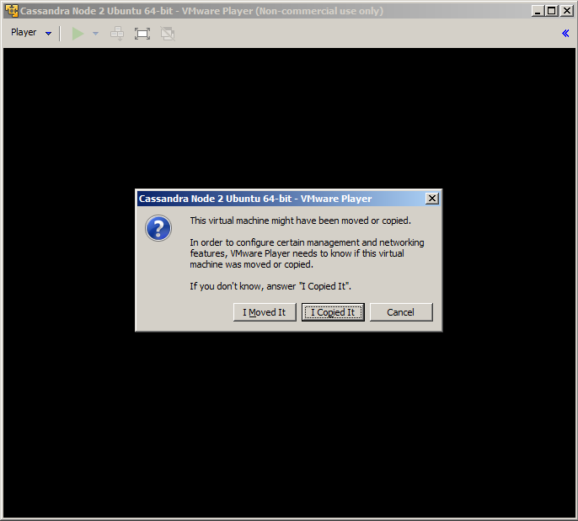

1. Change to static IP (se STATIC IP)
   1. Change to a unique IP address in the cluster
2. Delete Cassandra data (copied from another node so it must be removed)
   1. cd /home/node1/apache-cassandra-2.1.2/data
   2. rm -Rf *

# Add new Node to the cluster

NOTE, these instructions are valid for a copied node.

On the new node:

1. cd /home/node1/apache-cassandra-2.1.2/conf
2. vi cassandra-topology.properties
   1. Update the following: # Cassandra Node IP=Data Center:Rack
   2. Change to the Node IP address.
3. vi
   1. Change the following:
      1. listen_address <node IP>
      2. broadcast_rpc_address <node IP>